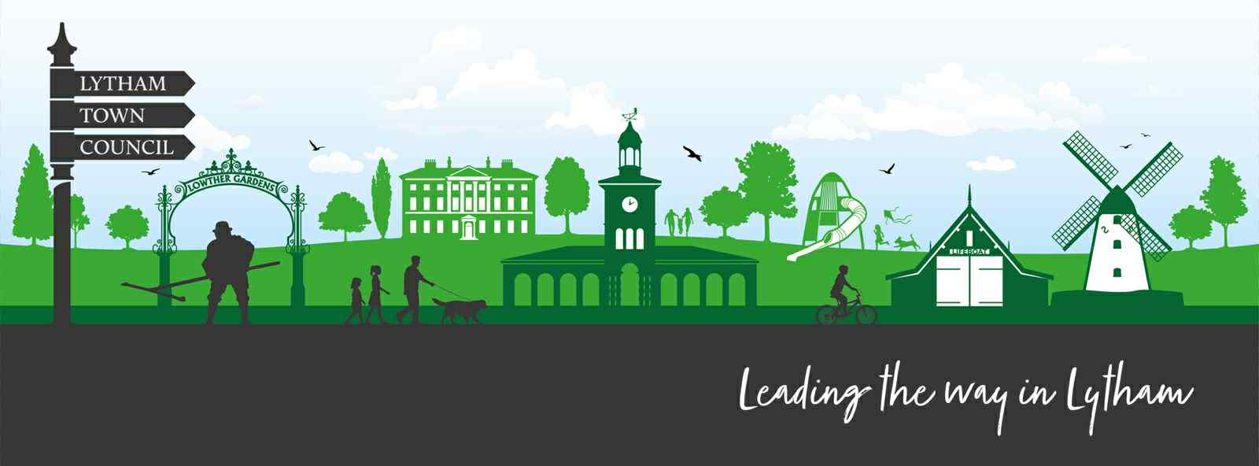

Lytham Town Council
c/o Lytham Institute
27 Clifton Street, Lytham, Lancashire. FY8 5EP
Email: Clerk@lythamtowncouncil.gov.uk
Web: www.lythamtowncouncil.gov.uk
Chair Cllr Simon Newell
Clerk: Mr Luke Russell

Lytham Town Council - Council Meeting

To: All members of Lytham Town Council.

You are hereby summoned to attend the Council Meeting of the Town Council to be held on Wednesday 29th April 2026 at 6.30pm at the Lytham Institute, 27 Clifton Street, Lytham, Lancashire, FY8 5EP.

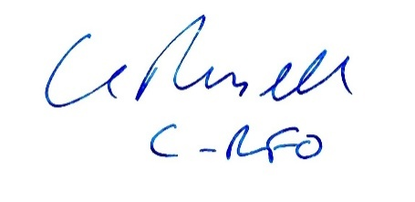
Mr Luke Russell MA
Clerk & Responsible Financial Officer
Thursday 23rd April 2026

Agenda – Wednesday 29th April 2026

Note regarding Finance & Audit items (Items 7–9):
This is the Council's first year-end. Items 7–9 cover the annual financial close and the Annual Governance and Accountability Return (AGAR) process for 2025/26. The Internal Audit Report has been received and is included with the agenda papers. Proper practice requires Section 1 (Annual Governance Statement) to be approved before Section 2 (Accounting Statements).

No. | Agenda Item | Decision? | Lead
PROCEDURAL MATTERS
1. | Welcome, introduction, Audio Recording notice and Health & Safety.  The Clerk will then confirm Member attendance and provide apologies for absence where they have been received. |  | CRFO &  Chair
2. | Declarations of Interest and Dispensations  - Councillors to declare any interests in agenda items.  - Consideration of requests for dispensations. |  | Cllrs
3. | Approval of Minutes  To consider and resolve the approval of the minutes as a true and accurate record for:  - Full meeting of the Council held on Wednesday 25th March 2026  - Extraordinary meeting of the Council held on Monday 13th April 2026 | Decision Item  Decision Item | Cllrs  Cllrs
4. | Public Participation (Open Forum)  (Max 15 minutes, 3 minutes per speaker)  • Members of the public may raise items with the Council in respect the business on the agenda.  The Chair may limit a member of the public to 3 minutes of speaking to ensure the smooth running of the meeting. Overall, the section will typically be limited to 15 minutes although the Chair, may at their discretion, extend this.
5. | Matters Arising / Action Points from Previous Meeting  Update on meeting of Lytham Festival Residents’ Group, attended by Cllr Bramall |  | Found at:  11
COMMITTEE REPORTS - RATIFICATION
6. | Community Grants, Honours & Awards (CGHA) Committee — Inaugural Meeting 22nd April 2026.  The Council is asked to receive and consider the report from the inaugural meeting of the CGHA Committee, held on 22nd April 2026, and to ratify the following:  - Election of Committee Chair — To receive notification of the Committee's election of Chair and to formally ratify that appointment in accordance with the Council's Standing Orders.  - Terms of Reference — To receive and resolve to adopt the Terms of Reference for the CGHA Committee as recommended by the Committee.  - Community Grant Scheme Applications (Round 1) — To receive the Committee's recommendations in respect of the two applications considered:  i. Application [LTC-G-(2025_26)-001] — Committee recommendation: AWARD  ii. Application [LTC-G-(2025_26)-002] — Committee recommendation: [Addition information being sought following Committee meeting on 22/04/2026 – no recommendation yet reached]  Council to resolve whether to accept, reject or amend each recommendation. | Decision Item  Decision Item  Decision Item
FINANCE, GOVERNANCE & AUDIT
7. | Finance Report — Receipts and Payments to Year-End 2025/26  To receive the written Finance Report from the Clerk / RFO showing receipts and payments against budget for the financial year ended 31st March 2026, including closing bank reconciliation and a comparison of actual versus budgeted figures for the year. |  | Clerk / RFO
8. | Internal Audit — Report and Recommendations  (Year-End 2025/26)  To receive and note the Internal Audit Report for the financial year ended 31st March 2026. The Council is asked to:  a) Note the findings, conclusions and any recommendations made by the Internal Auditor.  b) Discuss and resolve an appropriate response to any recommendations or matters highlighted in the report, and agree any remedial actions, assigning responsibility and timescales as appropriate.  c) Note that completion of the Internal Audit is a prerequisite for the Council proceeding to complete Sections 1 and 2 of the Annual Governance and Accountability Return (AGAR) (see Item 9 below).  NB: Note: The Internal Audit Report (page 3 of the AGAR) has been completed and signed by the Internal Auditor. This is received by Council for information and action; it is not completed by or signed by the Council. | Decision Item | Cllrs
9. | Annual Governance and Accountability Return (AGAR) 2025/26 — Approval  To consider and resolve approval of the AGAR for the financial year ended 31st March 2026.  The Council must deal with the sections in the following order:  a) Section 1 — Annual Governance Statement To consider and resolve the Council's responses to each of the governance assertions (Assertions 1–9, and Assertion 10 on digital and data compliance where applicable).  Council must answer 'Yes', 'No', or 'Not Applicable' to each assertion and approve Section 1 BEFORE Section 2.  NB: Note: The Annual Governance Statement is the responsibility of the Council, not the Clerk or Internal Auditor. By approving these assertions, the Council confirms it is satisfied with its own governance arrangements. The Chair and Clerk will sign Section 1 following Council approval.  - Section 2 — Accounting Statements  To receive and resolve to approve the Accounting Statements for 2025/26 as prepared by the Clerk / RFO. The Accounting Statements must be approved by the Council AFTER Section 1. Note: The Accounting Statements will be signed by the RFO and the Chair following Council approval.  c) Exercise of Public Rights — Notice and Period  To receive from the Clerk the proposed date range for the 30-working-day period for the Exercise of Public Rights, which must include the first 10 working days of July 2026. Council to note and approve the proposed notice period, after which the Clerk will publish the required notices on the Council's website and noticeboards.  - Background note for members: The AGAR is completed under the Local Audit and Accountability Act 2014 and the Accounts and Audit Regulations 2015. The Practitioners' Guide 2025 (issued by SAPPP/NALC/SLCC) sets out the proper practices applicable to the financial year ending 31st March 2026. | Decision Item  Decision Item  Decision Item  Decision Item
10. | To receive, discuss and resolve the adoption of the following Policies.  - Annual Treasury Management and Investment Strategy 2026-27  - Counter Fraud and Corruption  - Supplier and Procurement Counter-Fraud Policy  - Document Retention and Disposal Policy | Decision Item
REPORTS FROM OUTSIDE BODIES
11. | To receive any reports from Councillors serving as representatives on outside bodies.  - Update on meeting of Lytham Festival Residents’ Group, attended by Cllr Bramall  To note technological advancement of VodafoneThree ‘Slice’ product to create addition, dedicated 5G mobile signal for / within events |  | Cllr Bramall  Cllr Newell
COMMUNITY ENGAGEMENT
12. | Community Engagement Strategy  To discuss and consider the opportunities around improvement the Council’s connections with the community through a more effective Communications / Community Engagement Strategy |  | Clerk / Cllr Bramall
ENVIRONMENT
13. | - Planters – Clifton Street.  To consider and resolve to appoint a lead to engage with potential providers and arrange a quotation, budget and organise the commissioning of planting and emplacement of the provided planters onto the lamp posts on Clifton St.  - Christmas Lights.  To note update regarding visit to Blackpool Council’s ‘Lightpool’ facility and proposed next steps in obtaining designs, quotations and initial, outline plans  - Heritage & Art Trails into Lytham Town Centre  To consider options to support heritage and art groups with plans for trails into the town centre  - Benches around trees on Clifton Street.  To consider options for the provision of semi-circular benches to be fitted at the base of trees on Clifton Street  - Refurbishment of Telephone Boxes.  To consider the purpose, purchase, refurbishment and installation of decommissioned GPO / BT red telephone boxes for Lytham. (Note: Other locations have used these for the installation of AED or book libraries) |  | CRFO  Cllr Blackshaw  Cllr Newell / Clerk  Cllr Bamforth  Cllr Blackshaw
PLANNING & LICENSING
14. | Planning Applications and Licensing Matters  To receive and consider any planning applications or licensing matters notified to the Council since the last meeting.  - No new planning applications raised for the attention of Council.  - To consider correspondence from Mr Chris Hambly (FBC – Licensing) regarding the Proposed Amendments to FBC’s Statement of Licensing Policy.  This may be seen Licensing Policy Statement – Fylde Council  Comments are requested by 29th May 2026  - To consider correspondence from Mr Chris Hambly (FBC – Licensing) regarding the Proposed Amendments to FBC’s Statement of Gambling Policy. (documents circulated)  Comments are requested by 29th May 2026 |  | CRFO  CRFO
CORRESPONDENCE
15. | Correspondence  To note significant correspondence received since the last meeting and to determine any action required.
FORWARD PLANNING
16. | Preparation for Annual Council Meeting — 6th May 2026 To note matters which will be required for the Annual Council Meeting on 6th May 2026, including (but not limited to):  • Election of Chair of the Council  • Election of Vice-Chair of the Council  • Review and re-adoption / amendment of Standing Orders • Review and re-adoption / amendment of Financial Regulations  • Review of delegated authorities and committee appointments  • Any other Annual Council business  Councillors are invited to raise any preparatory matters for the Clerk to include on the Annual Council agenda.
17. | Preparation for Annual Town / Parish Meeting — 13th May 2026  To note the requirements for the Annual Town Meeting on 13th May 2026 as required under Schedule 12, Part III, paragraph 14 of the Local Government Act 1972, and to receive any preparatory updates from the Clerk.
18. | Items for Next Agenda  Councillors to request topics for inclusion in the next Full Council Meeting agenda – 10th June 2026
19. | Date, Time & Location of Next Meeting  Annual Council Meeting:  Wednesday 6th May 2026  6:30pm  Lytham Institute, 27 Clifton Street, Lytham, Lancashire, FY8 5EP
Signed:
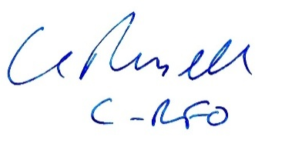

Mr Luke Russell MA, Clerk & Responsible Financial Officer
Date: 23rd April 2026
This agenda is published online at www.lythamtowncouncil.gov.uk and circulated via the Council's Facebook page. Circulated to: All Councillors; Notice Board (Lytham Institute); Council Website. Press and public are welcome to attend.

